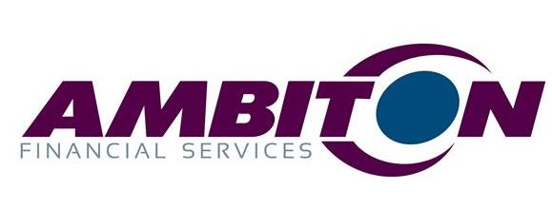
BOARDROOM RESERVATION FORM

NAME OF COMPANY:
NAME OF COMPANY REPRESENTATIVE:
CONTACT NUMBER OF COMPANY REPRESENTATIVE:
DATE OF BOARDROOM RESERVATION:
TOTAL GUESTS ATTENDING THE RESERVATION:
START TIME OF BOARDROOM RESERVATION:
END TIME OF BOARDROOM RESERVATION:
(Reservation may not to be later than 19h00)

PLEASE SELECT APPROPRIATE BEVERAGE REQUIREMENTS FOR YOUR BOARDROOM BOOKING:
FREE SERVICES THAT WE OFFER - COFFEE, TEA AND WATER
Filter Coffee
Tea (Rooibos / Original)
Filtered Water – Still
ADDITIONAL SERVICES INCLUDE THE FOLLOWING AT A COST TO THE LESSEE
Cold Drinks – Coca Cola, Coca Cola Light, Tab, Fanta Orange, Crème Soda, Sprite and Twist
Beers – Castle Lager, Castle Lite, Amstel, Black Label, Hansa, Windhoek Lager, Windhoek Draught and Flying Fish
Ciders – Brutal Fruit, Hunters Gold, Hunters Dry, Savanah Dry, Savanah Light, Smirnoff Twist
Liquor – Johnny Walker Black Label, J&B, Jameson, Bells, Richelieu and Captain Morgan Dark Rum
Spirits – Absolut Vodka, Smirnoff Vodka, Gordon’s Gin and Malvy Gin

LIQUOR BILL TO BE CHARGED TO
Name:
Postal Address:
Company VAT Registration (if applicable):

ADDITIONAL EQUIPTMENT – FREE SERVICE TO THE LESSEE
Wireless Internet (Wi-Fi)
Projector Screen
Data Projector
Extension Cord
Flip Chart and Cockeyes

Signature of Company Representative

PARKING ALLOCATIONS

We have 8 parking bays available for you to utilise in the front of the Ambiton building for the duration of your reservation. Below is a representation of where these parking bays are:

AMBITON HOUSE | GARAGE | VISITOR PARKING | VISITOR PARKING
 | VISITOR PARKING
 | VISITOR PARKING
 | VISITOR PARKING
EMERGENCY
EXIT DOOR
 | VISITOR PARKING
 | VISITOR PARKING
 | VISITOR PARKING
 | FRONT GATE

Signature of Company Representative

